Java Medical User Manual

Thank you for choosing our product to help your employees and patients with their medical information. This guide will help you guide through the program so that you are able to use this program in a safe and secure way. This manual will start from the beginning and split off to where you need to go. Our goal for the manual is to help you understand and use this program.

1. To start off with our program, you will be welcomed by our logo and three options. This is the main menu of our program. The options that you can choose are Patient Login, Employee Login, or Exit Program. 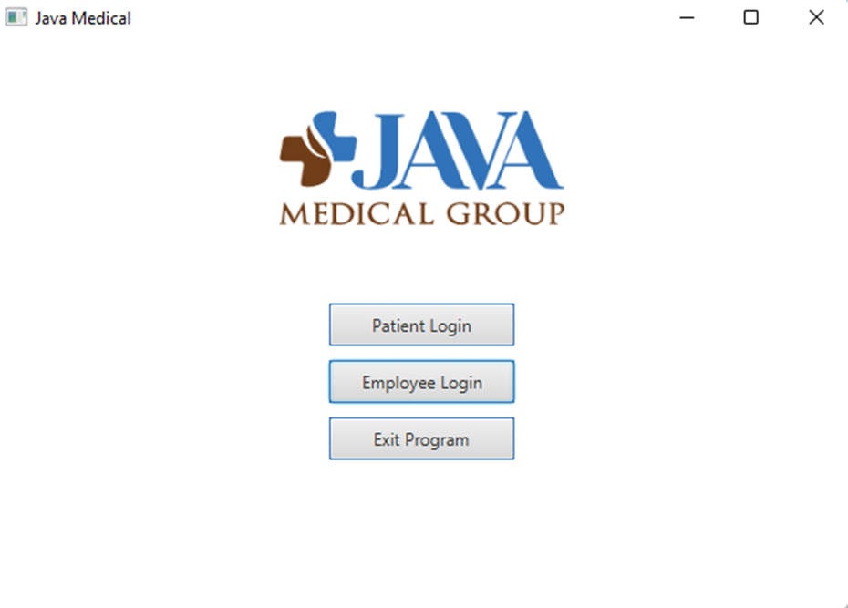
2. The first option to look at is the Patient Login. To begin, click on the first option to take you to that screen. The program will switch over to the Patient Portal. The first thing to notice is that the area is blue. The blue represents that this is the patient side of the program. To access further, information needs to be provided to log in. If the user is a new person, there is also an option to register. One thing to notice is that there is a home icon. At any time the user needs to go back to the menu, clicking the home button will take them there. The next step is continuing if the user already has an account. Graphical user interface, application

   Description automatically generated
3. Once an account member logs in, They will be taken to a screen that will have their information. It will provide the appointment date, time, the doctor, notes, medicen name, and prescription fill date. This is what the patient will see once they log in. If they need to leave, they can click the home button to log out. Graphical user interface, application

   Description automatically generated(For Example use only)
4. For the new users, once they click the registration button the screen will change to a registraion to where the user will enter information to make a new account. Once the account is made, the screen will be blank until a doctor contacts them to make a new appointment. Like the registerd account, to log out click on the house icon.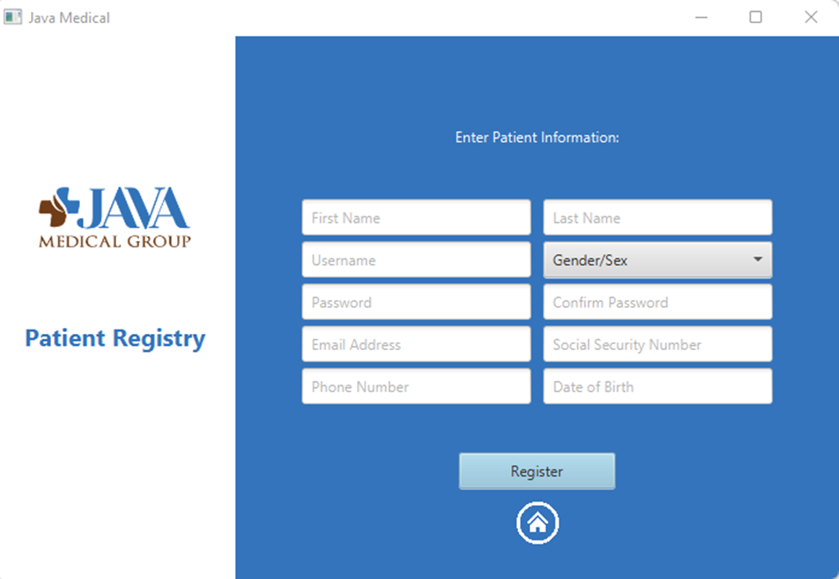Chart, treemap chart

   Description automatically generated
5. For the employees, to choose this option click the second option from the main menu. Once chosen, the first thing to notice is that the color is now brown. This indicates that this is the employee section of the program. Another thing to notice is that there is no registration. To get log-in credentials, the user will have to be employed and given the credentials from the director of the hospital. Our program does not let anyone to make an account in the employee portal. Graphical user interface, application

   Description automatically generated
6. Once passed the login page, the employee would be greeted to this screen. This gives the doctor the information about the patients that they are seeing. This gives them the patient ID, name, gender, email, and date of birth. The employee can double click on a patient, and it will go to the patient’s chart as well. To log out, just click on the house icon as well.Table

   Description automatically generated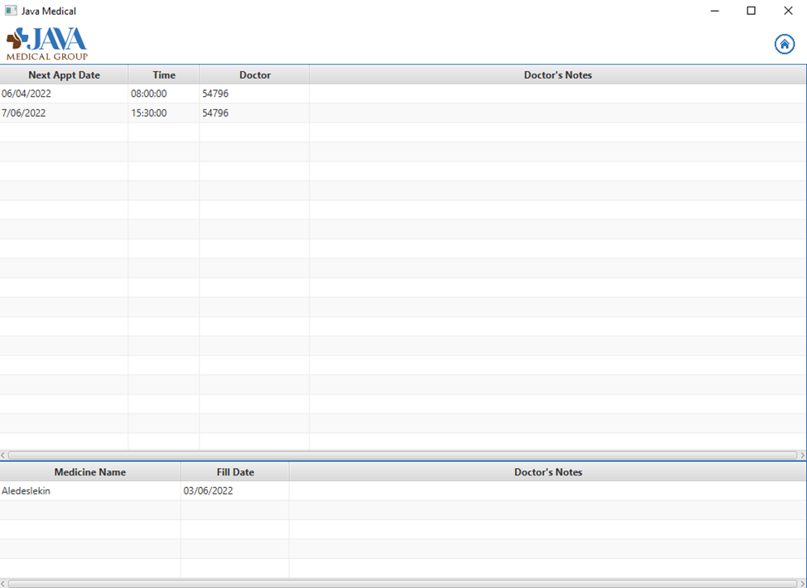(For example use)
7. To leave the program, just click on the Exit Program at the main menu and the program will close.

Thank you for choosing our product for your medical needs. We hope that you enjoy this program. If need to contact with any troubleshoot. Call the Java Medical Company.